Discover Bali with INTRO TRAVELS INDIA
Bali, the “Island of the Gods,” is one of the most beautiful destinations in Indonesia, famous for tropical beaches, stunning temples, lush rice terraces, volcanoes, nightlife, and wellness retreats. Whether you are planning a honeymoon, friends trip, solo adventure, or luxury vacation, Bali offers the perfect mix of relaxation and adventure.
Why Visit Bali?
- Exotic beaches & cliffside sunsets
- Beautiful Hindu temples & Balinese culture
- Affordable luxury villas and resorts
- Adventure activities like surfing, snorkeling & trekking
- World-famous cafés, beach clubs & nightlife
- Romantic honeymoon destination
- Friendly locals and vibrant markets

Best Places to Visit in Bali
1. Ubud – The Cultural Heart of Bali
Known for:
- Rice terraces
- Yoga retreats
- Waterfalls
- Art markets
- Traditional Balinese culture
Top attractions:
- Tegalalang Rice Terrace
- Monkey Forest
- Tirta Empul Temple
- Bali Swing



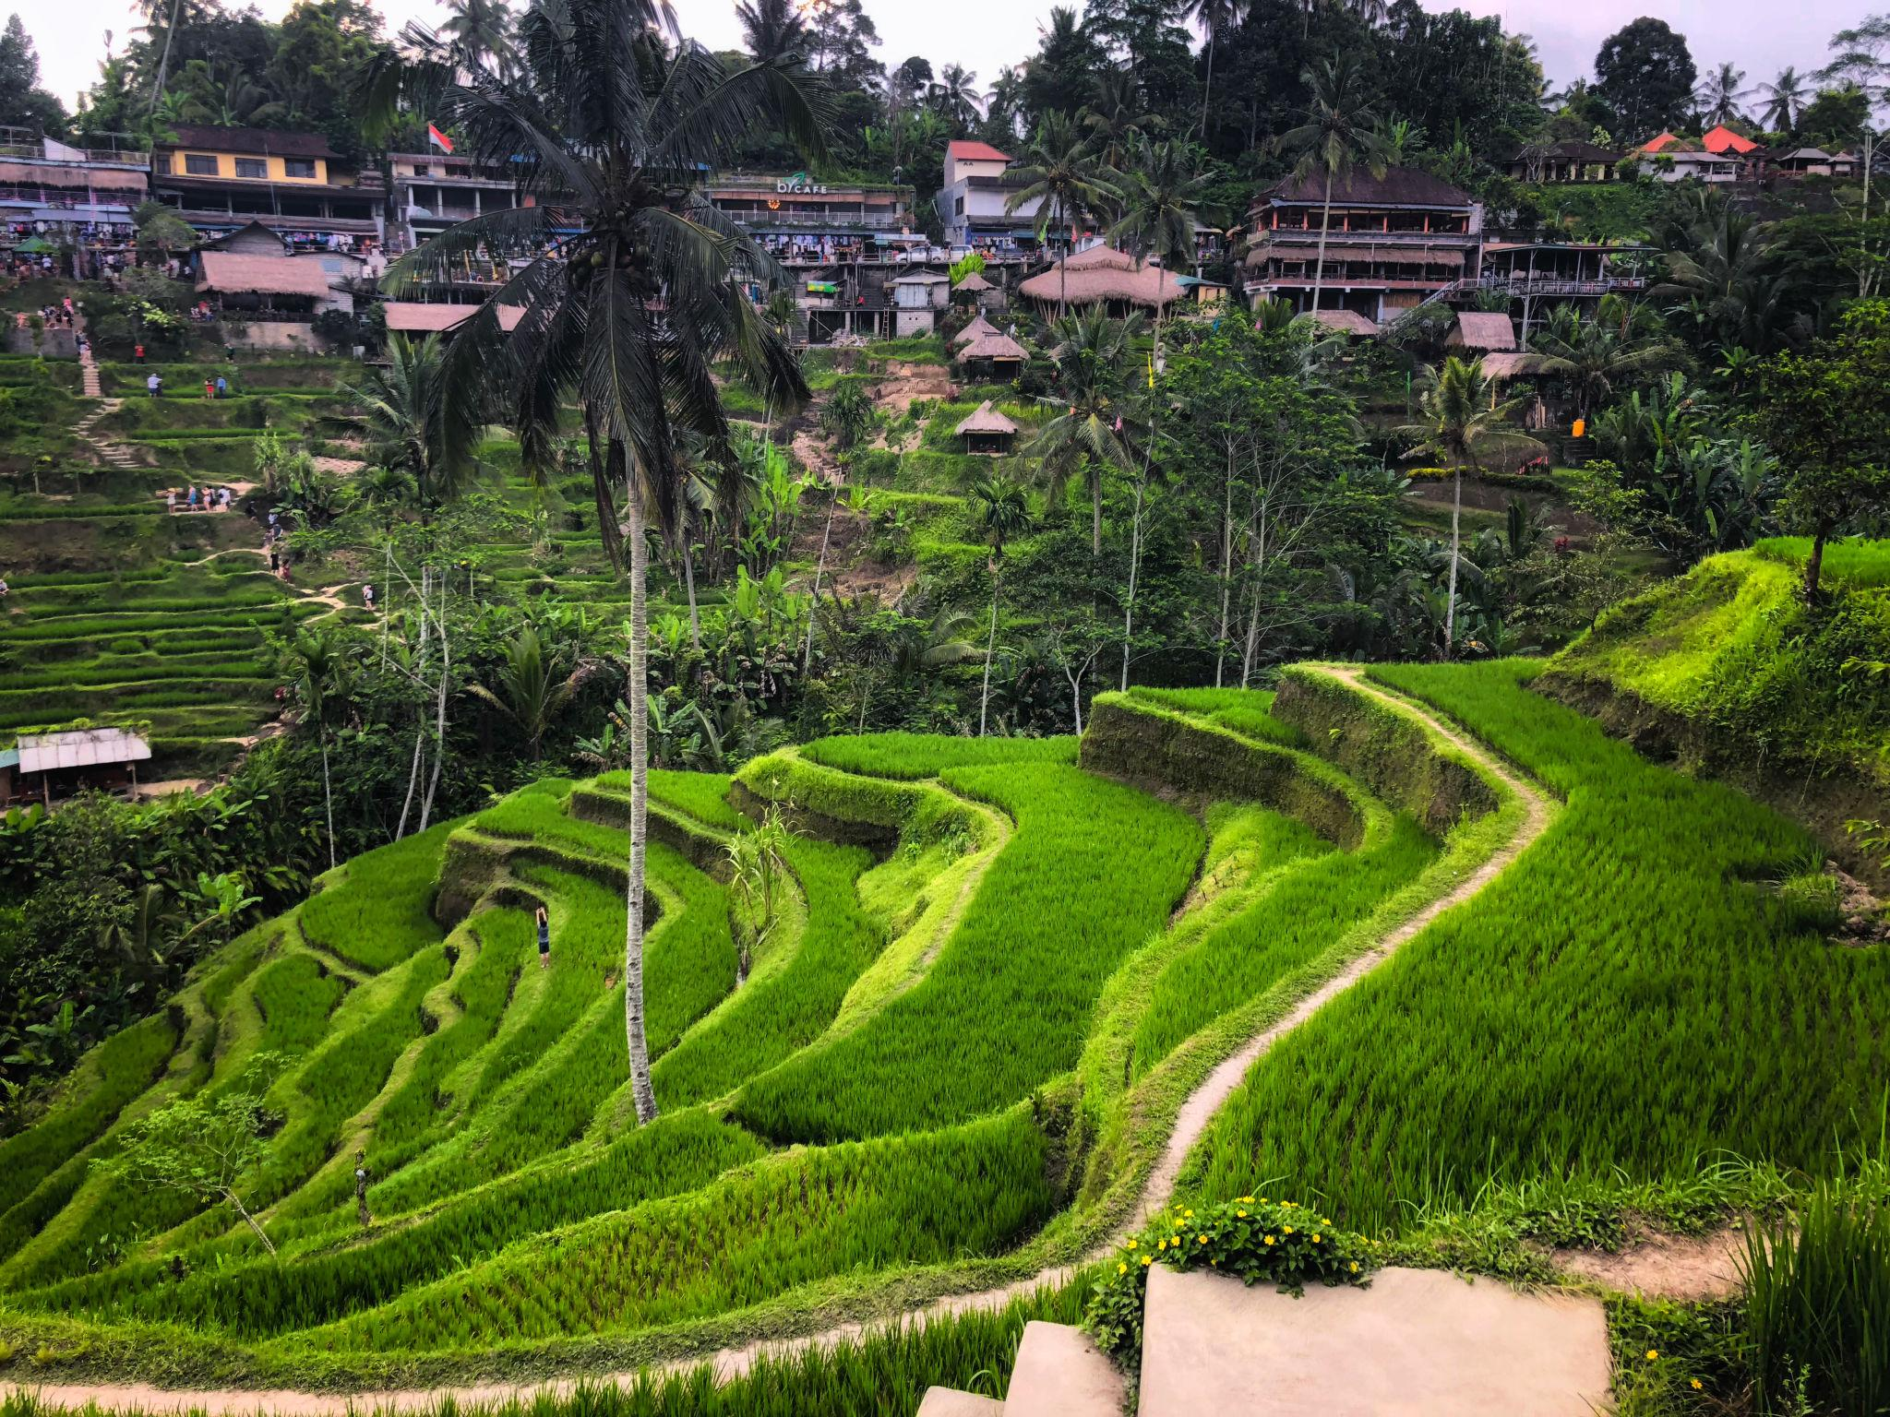



2. Seminyak – Luxury & Beach Clubs
Perfect for:
- Luxury resorts
- Beach clubs
- Sunset cafés
- Shopping
- Nightlife
Popular beach clubs:
- Potato Head
- KU DE TA
- Finns Beach Club





3. Uluwatu – Cliffs & Surf Paradise
Famous for:
- Dramatic cliff views
- Surf beaches
- Sunset temples
- Romantic dining
Must visit:
- Uluwatu Temple
- Padang Padang Beach
- Kecak Fire Dance
(Rough Guides)

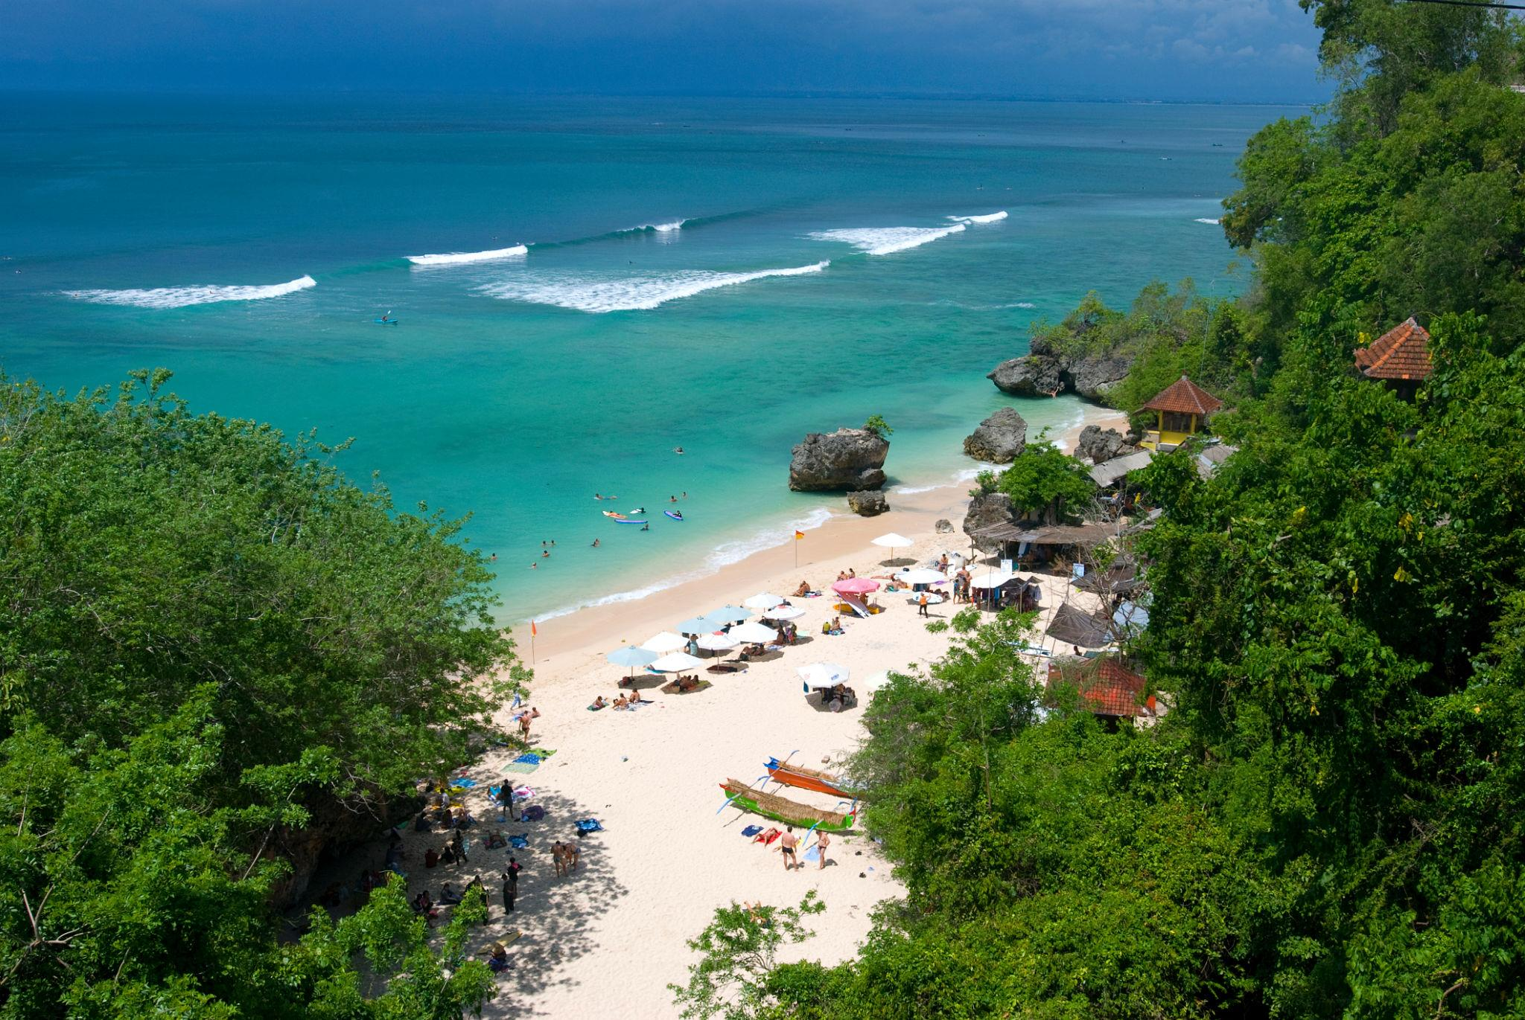



4. Nusa Penida – Instagram Paradise
Highlights:
- Kelingking Beach
- Broken Beach
- Crystal Bay
- Snorkeling with manta rays
(Rough Guides)
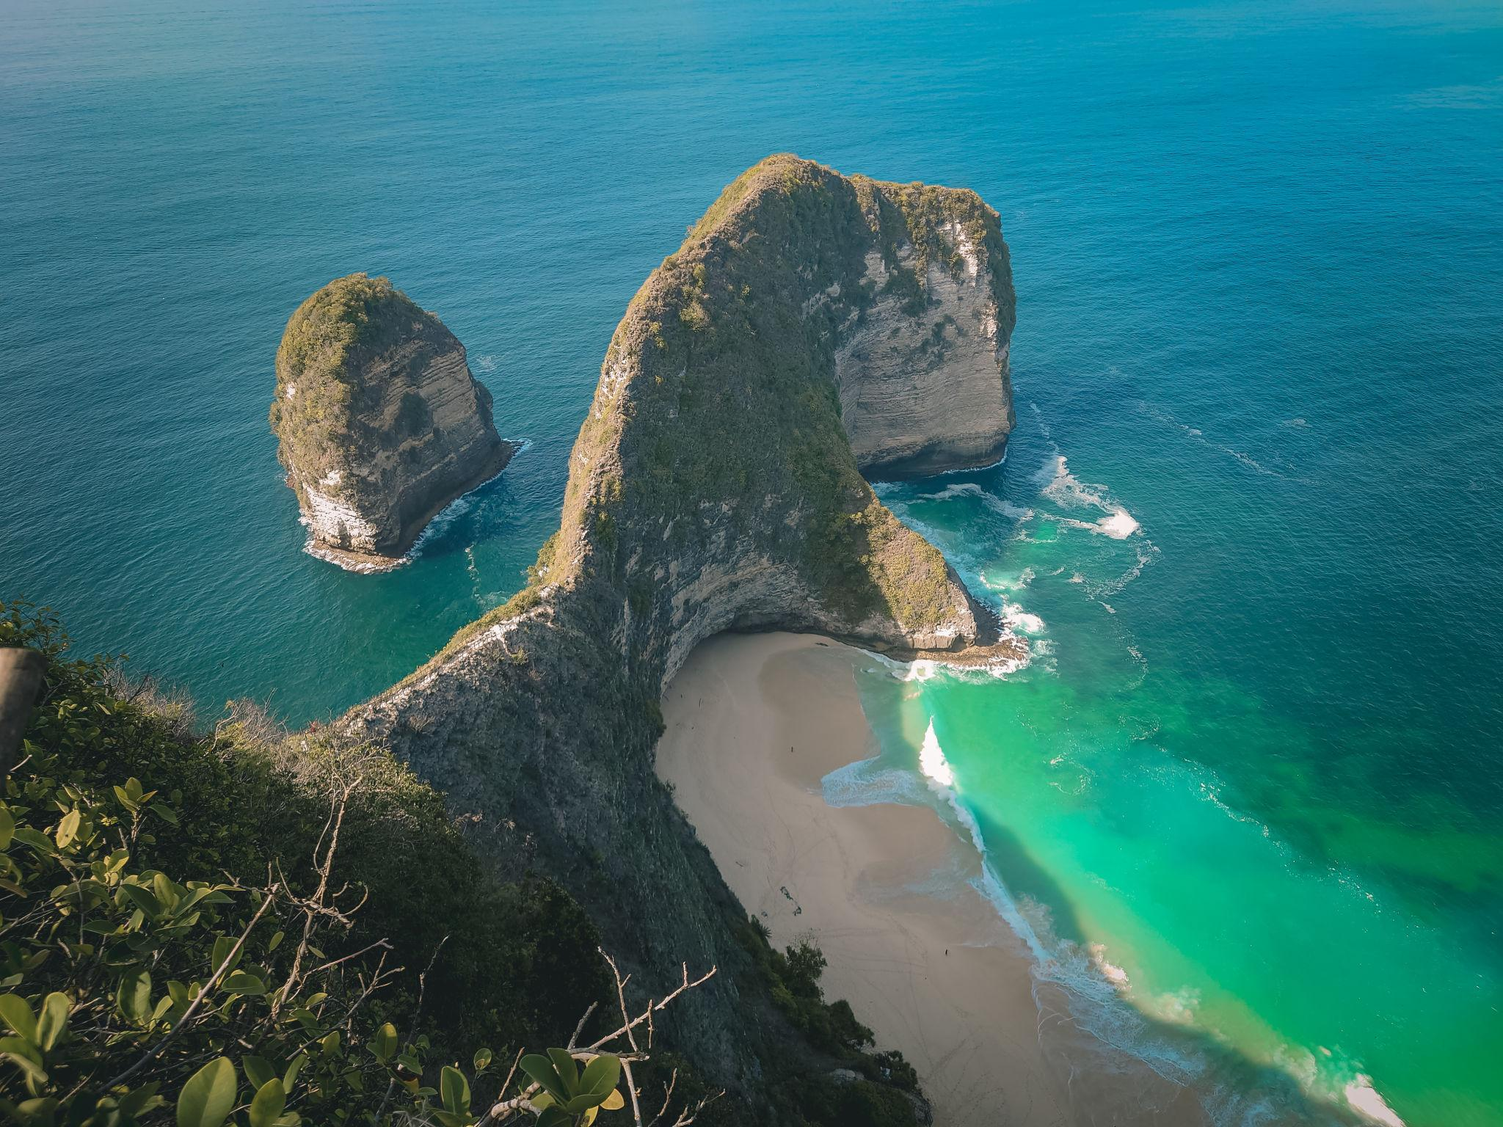
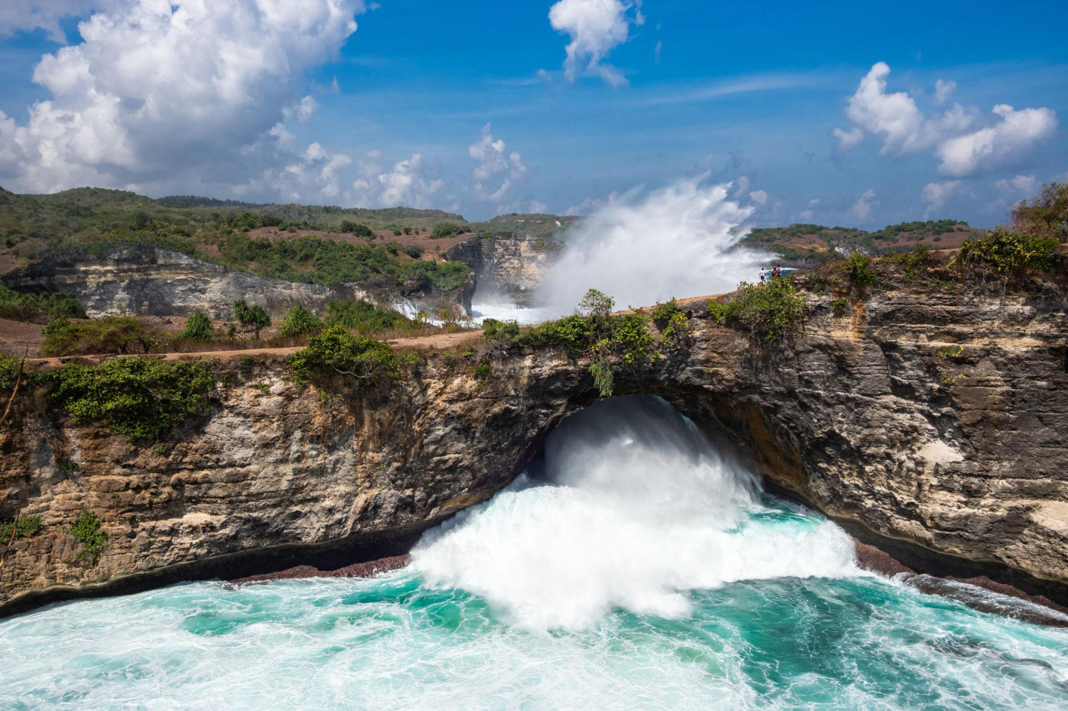
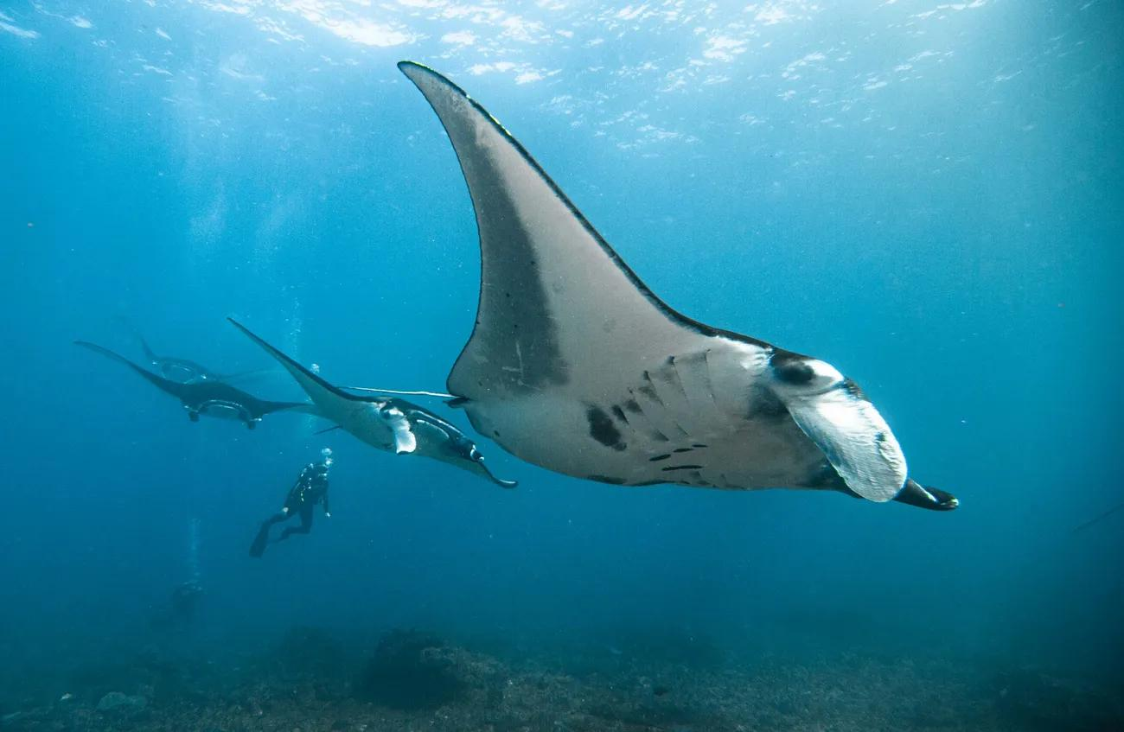

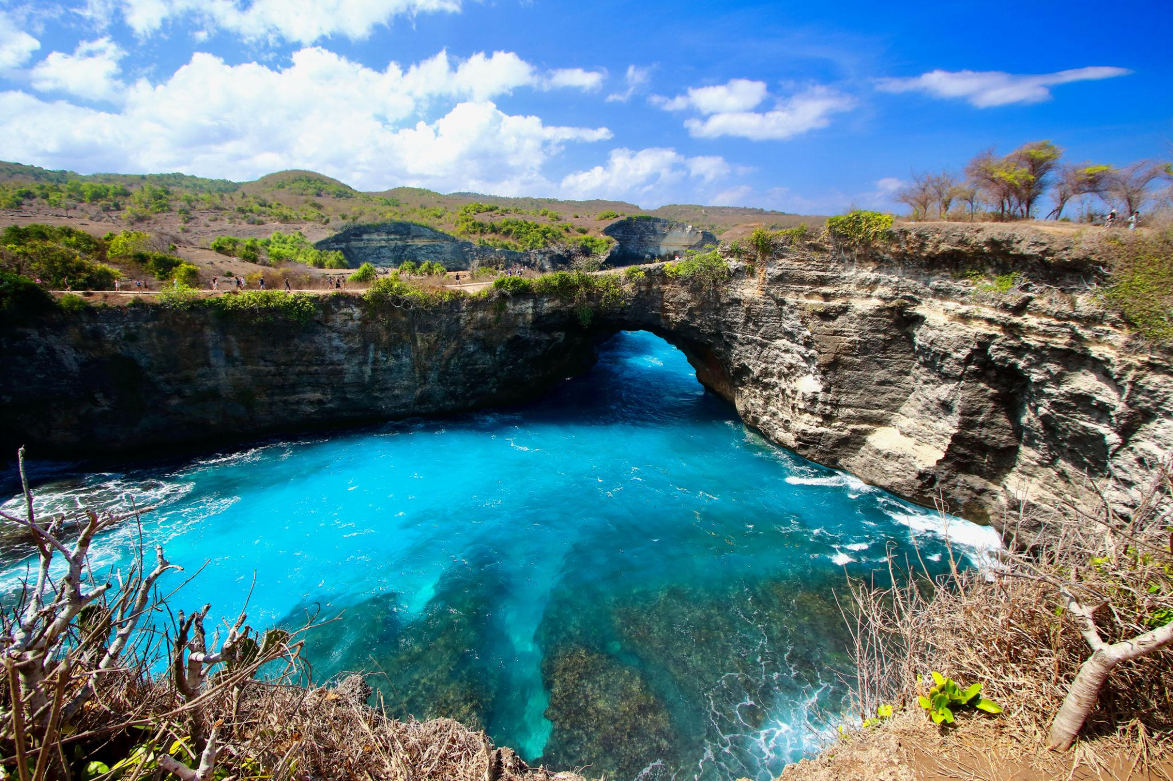

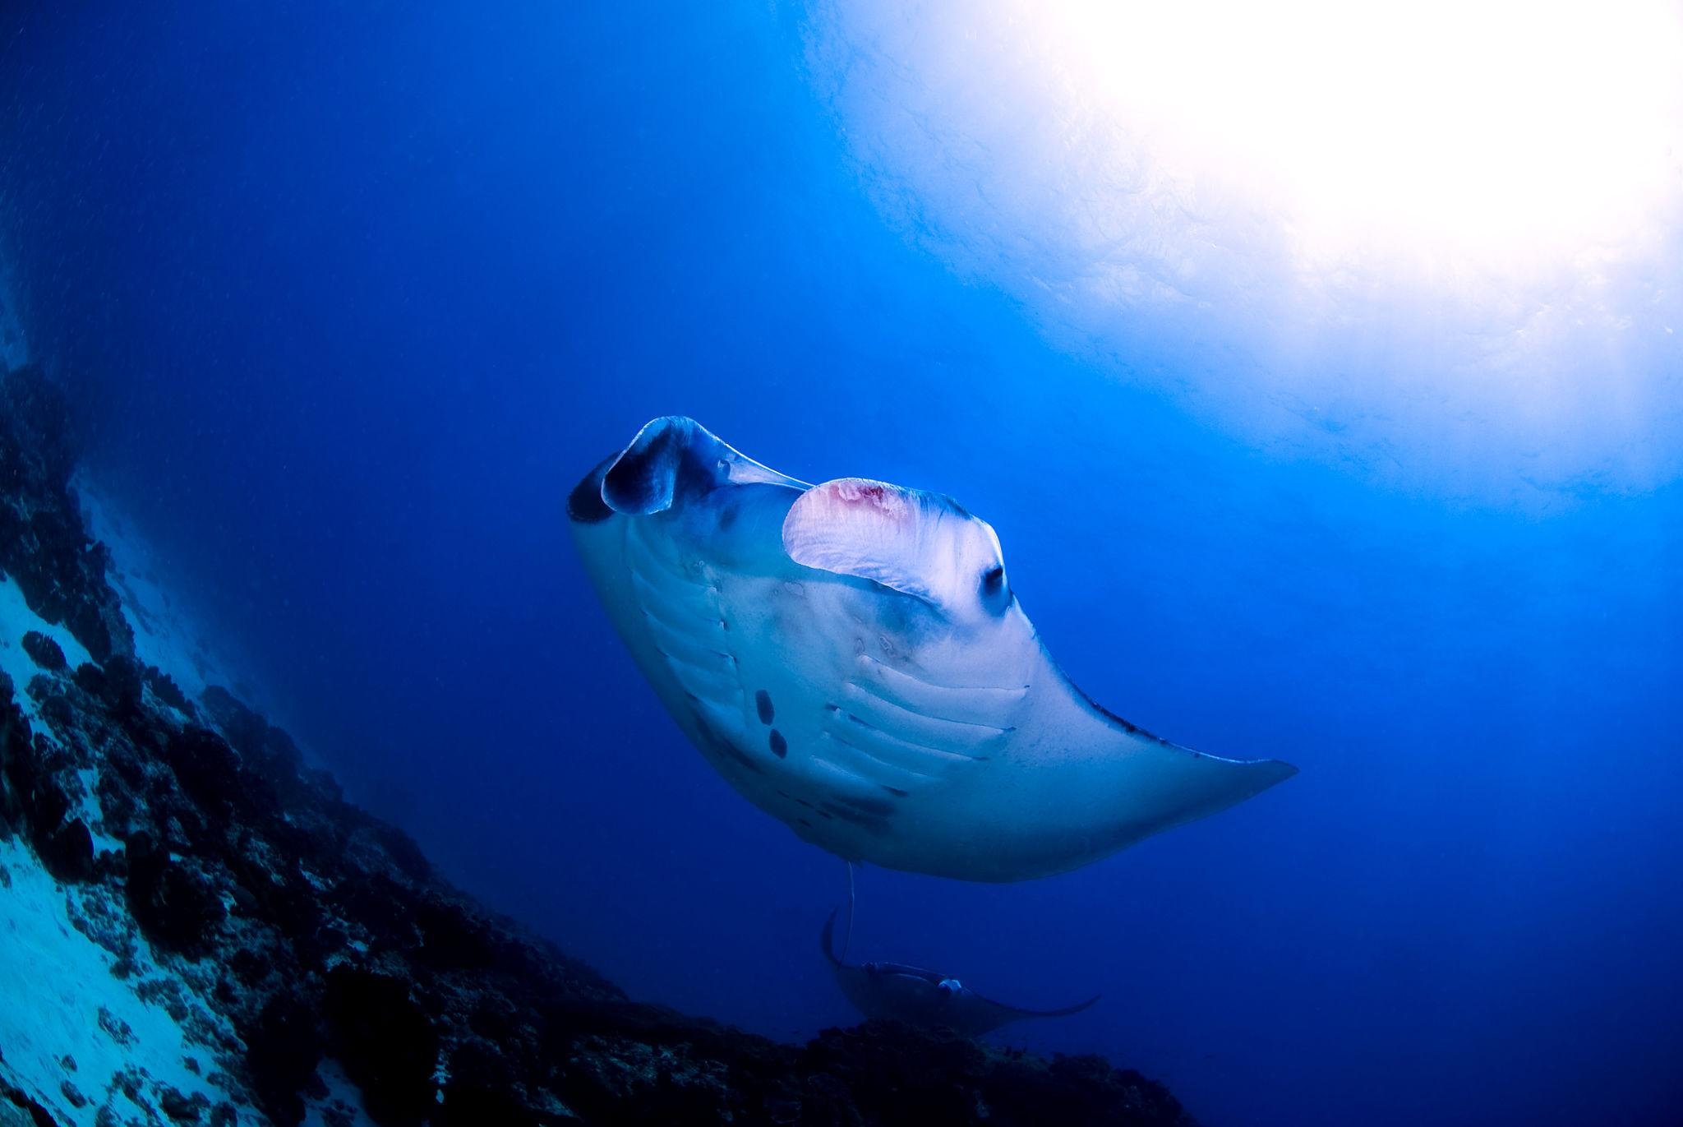

Best Things to Do in Bali
- Watch sunset at Tanah Lot Temple
- Trek Mount Batur at sunrise
- Enjoy Balinese spa treatments
- Take a Bali swing photo
- Visit waterfalls in North Bali
- Experience traditional Balinese dance
- Snorkeling & scuba diving
- Surfing in Kuta & Canggu
- ATV rides & river rafting
(hotels)

Best Time to Visit Bali
Season | Months | Weather
Dry Season | May – October | Best for beaches & outdoor activities
Wet Season | November – April | Lush greenery & cheaper hotels
The ideal months are May, June, and September because the weather is pleasant and crowds are lower.

Bali Visa for Indians 🇮🇳
Indian travelers usually require:
- Passport valid for 6 months
- Return tickets
- Hotel bookings
- Sufficient funds
Indonesia also warns tourists to use official e-visa channels and follow local cultural rules respectfully. (The Economic Times)

Bali Travel Tips
- Carry light cotton clothes
- Use sunscreen & mosquito repellent
- Respect temple dress codes
- Use Grab/Gojek for cheap transport
- Carry Indonesian Rupiah cash
- Avoid drinking tap water

Bali Food You Must Try 🍜
- Nasi Goreng
- Mie Goreng
- Satay
- Babi Guling
- Balinese seafood
- Tropical smoothie bowls
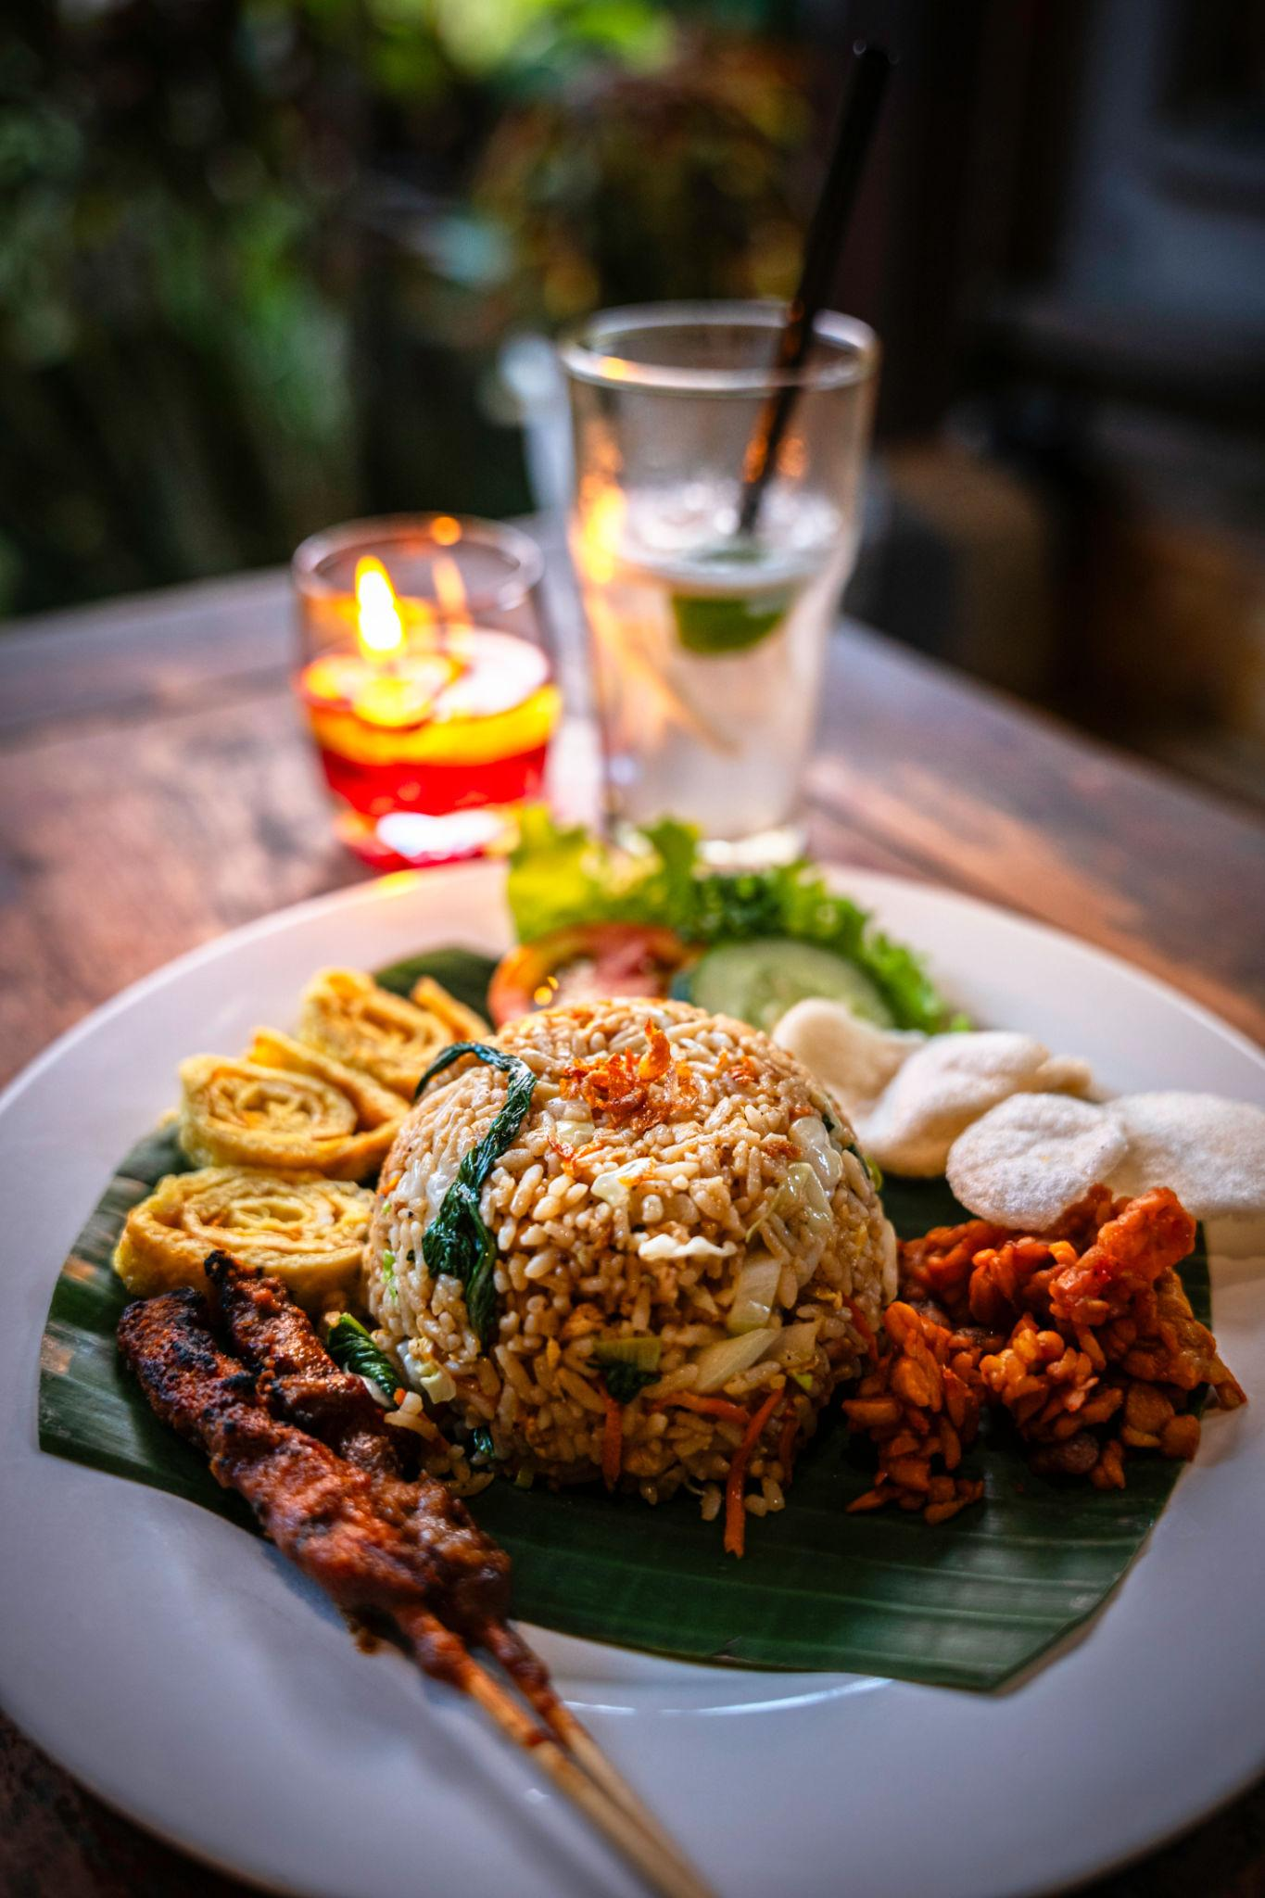
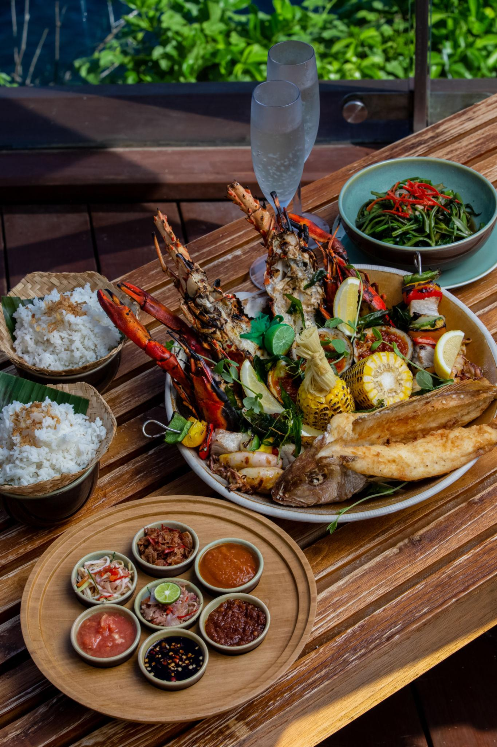
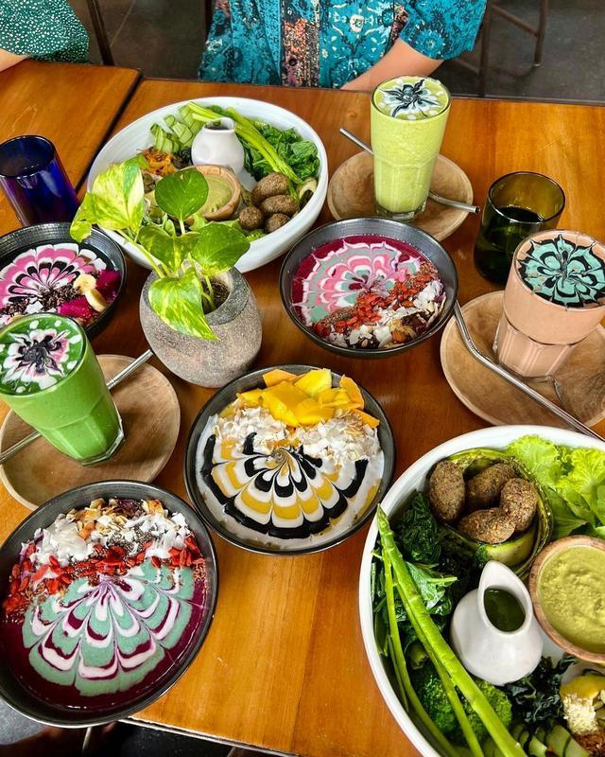



Why Choose INTRO TRAVELS INDIA for Bali?
With INTRO TRAVELS INDIA, you can enjoy:
- Customized Bali packages
- Honeymoon planning
- Group tours
- Luxury villa stays
- Airport transfers
- Adventure activities
- Indian food options
- Local guided tours
Bali is perfect for travelers seeking beaches, spirituality, luxury, adventure, and unforgettable sunsets — all in one destination.

